Design document

Project description:

A set of 3 pages describing what I bring to a job or research environment, as well as a small peak into my personal life (while still staying fully work-appropriate to potential employers!)

My creative component is the data on birdwatching.html. I downloaded my exisiting library reading history (and manually curated the contents to have only nature-associated books) and downloaded my birdwatching history from eBird. I try to read every night at 9:30PM to wind down for bedtime, so there were over 500 items that I’d checked out from the library on the list! Of course, some of the 500 were picture books I got for the toddler nextdoor and some I hadn’t finished but called it quits and returned after the 2 week checkout duration.

User Personas:

* Potential industry employers
* Academic hiring committee
* People interested in working with me on academic research (may range from undergrad to tenured professors).
* Potential PhD students curious about my path

User stories (use cases but with a story):

* Potential industry employers: I’m applying for a job and a hiring manager clicks a link on my resume. They need to get a feel for who I am and what my skills are, and FAST even though my projects have been so varied. Here’s an overview of what I bring to the table.
* Academic hiring committee: I might apply for academia jobs. Why would I be a good professor at… a liberal arts college? A R1 research university?
* People interested in working with me on academic research (may range from undergrad to tenured professors): having a good collaborator is valuable. Someone should be able to skim through my profile and see if I have experience in a topic and publish in venues they are interested in.
* Potential PhD students curious about my path: a potential PhD student wants to vet an advisor before committing to a 5 year degree. What have other PhDs from that advisor done? Is it what they want to do or too different? I need to show my authentic self and not misrepresent my reality.

Design mockups:

Page 1: Professional, academic homepage



Page 2: My outdoor birdwatching adventures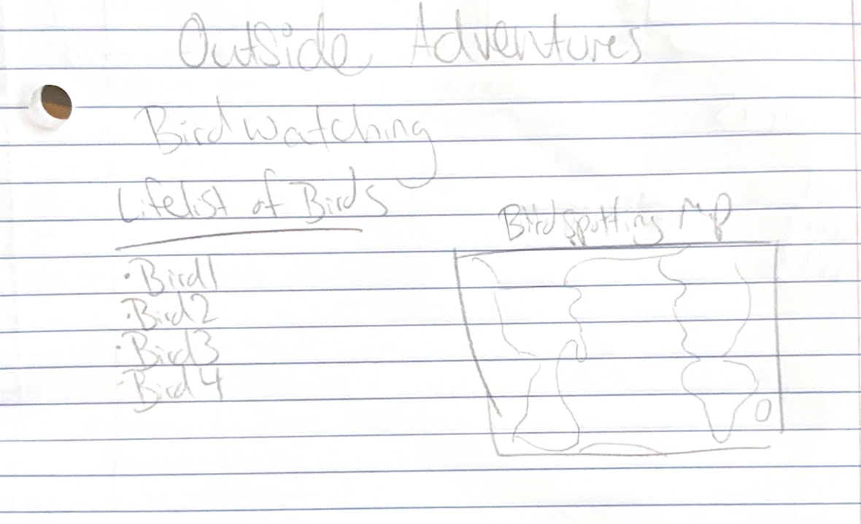

Page 3: vibe coding (the AI generated page)

A bunch of pictures of birds that rotate through on a carrousel.